**Lead Source Performance Analysis**

**Introduction:**

This report delves into the performance of our lead generation sources, highlighting both the quantity of leads and their quality in terms of conversion. By identifying the platforms that are driving the most leads and the sources that deliver the highest conversion rates, we aim to refine our marketing and lead-generation strategies for better overall outcomes.

**Segment 1: Sources with the Highest Lead Volume**

**Overview:**

To start, we analyzed the lead volume across our various platforms to determine which channels are driving the most leads.

**Key Insights:**

* **Top Performers – Facebook, LinkedIn, and Zoom Webinar**:  
  The data clearly shows that Facebook, LinkedIn, and Zoom Webinar are our leading platforms in terms of lead volume. Facebook tops the chart with the highest number of leads generated, followed closely by LinkedIn and Zoom Webinar. These platforms have proven to be highly effective in reaching potential customers and driving significant traffic to our funnel.

**Key Point to Emphasize:**  
Given the high lead volume from Facebook, LinkedIn, and Zoom Webinar, it's crucial to continue investing in these channels. Further scaling of our marketing efforts on these platforms could yield even greater results in terms of lead acquisition.

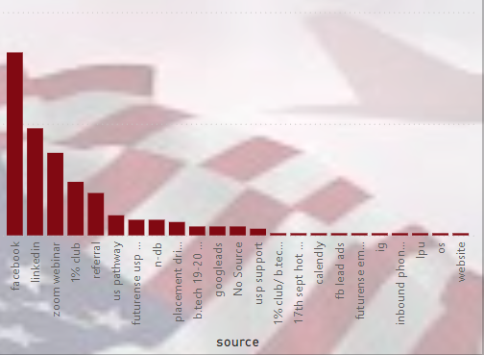

**Segment 2: Sources with the Highest Conversion Rates**

**Overview:**

Next, we turned our attention to the quality of leads—specifically, those that result in active opportunities. Here, the data shows a stark difference in the performance of certain channels.

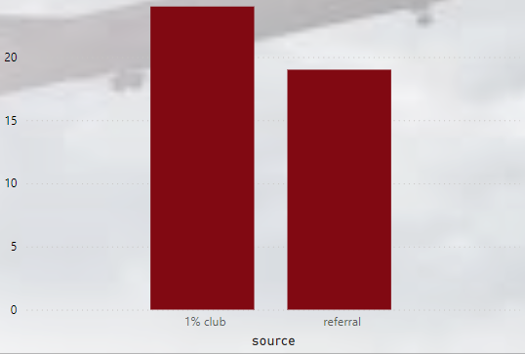

**Key Insights:**

* **High-Quality Leads – 1 Percent Club and Referrals**:  
  When it comes to conversion rates, the 1 Percent Club and Referrals stand out with an exceptional 100% conversion rate. This means that every lead generated from these sources has turned into an active opportunity, making them the most reliable sources for high-quality leads.

**Key Point to Emphasize:**  
While platforms like Facebook and LinkedIn are driving the volume, 1 Percent Club and Referrals are generating the most valuable leads in terms of conversions. Balancing efforts between these high-volume and high-quality channels will be critical for optimizing our sales pipeline.

**Proposed Solutions:**

Based on the insights gained from this analysis, the following strategies are recommended to maximize the effectiveness of our lead-generation efforts:

1. **Double Down on High-Performing Sources**:  
   **Solution**: Continue investing heavily in Facebook, LinkedIn, and Zoom Webinar to maintain and potentially increase the volume of leads coming from these platforms.  
   **Impact**: Expanding efforts on these platforms will help sustain a high flow of leads, keeping the top of our sales funnel filled with potential opportunities.
2. **Nurture High-Quality Channels**:  
   **Solution**: Prioritize lead sources like 1 Percent Club and Referrals, which have shown a strong track record of converting leads into active opportunities. Explore strategies like expanding referral programs or personalizing outreach to further capitalize on these high-conversion channels.  
   **Impact**: By focusing on nurturing high-quality leads from these sources, we can ensure that a greater proportion of our efforts result in successful outcomes.
3. **Balance Quantity with Quality**:  
   **Solution**: Track and refine the balance between platforms that generate the most leads and those that deliver the highest conversions. This balanced approach will allow us to optimize both the quantity of leads and their likelihood of converting into sales.  
   **Impact**: Striking this balance will lead to a more efficient sales process, ultimately improving both our lead volume and conversion rates.

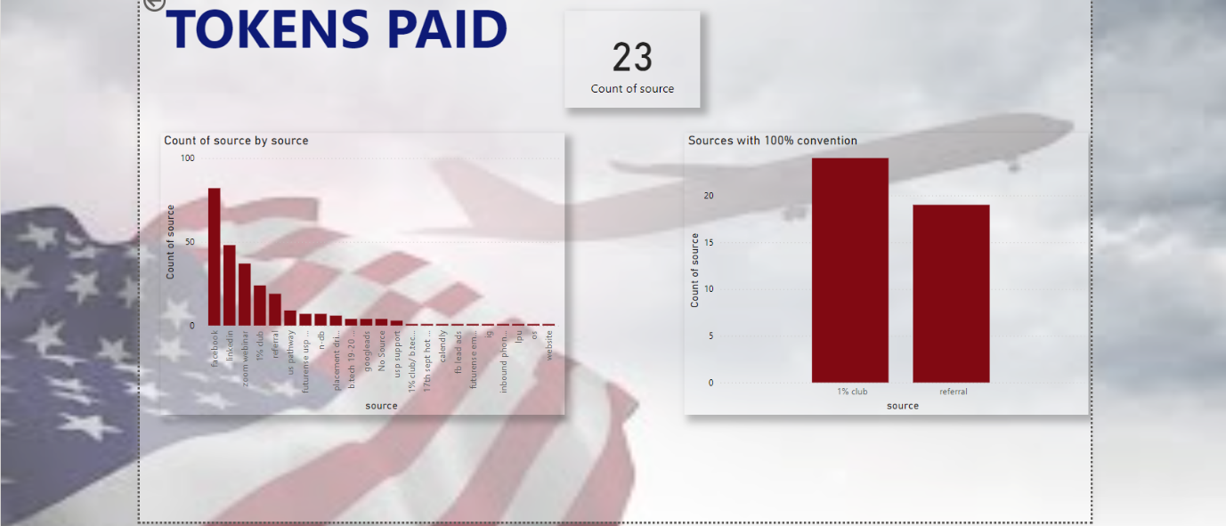

**Conclusion:**

In conclusion, by leveraging the strengths of both high-volume platforms like Facebook and LinkedIn, and high-conversion sources like 1 Percent Club and Referrals, we can better align our strategies to drive more meaningful results for the business. Focusing on the balance between quantity and quality will be key to optimizing our lead generation and ensuring sustained growth in the sales pipeline.